







This tutorial walks you through most the steps involved in converting the items only application into an application that has contacts. The steps in this tutorial are:

**Table of Contents**

Step 1. Clear the App Memory 2

Step 2. Add a Menu 4

Step 3. Create the ContactsActivity Class 8

Step 4. Implement the ContactsActivity Layout Resource File, activity_contacts.xml 10

Step 5. Create and Implement a Layout Resource for a Contact Display in the List of Contacts: contactlist_contact.xml 11

Step 6. Create and Implement the ContactAdapter Class 14

Step 7. Implement the ContactsActivity Class 16

Step 8. Update the Item Class 19

Step 9. Update the ItemList Class 21

Step 10. Create the AddContactActivity Class 22

Step 11. Implement the AddContactActivity Layout Resource File, activity_add_contact.xml 23

Step 12. Implement the AddContactActivity Class 25

Step 13. Create the EditContactActivity Class 27

Step 14. Implement the EditContactActivity layout resource file, activity_edit_contact.xml 28

Step 15. Implement the EditContactActivity Class 31

Step 16. Update the EditItemActivity Class 33

Step 17. Update the EditItemActivity layout resource file, activity_edit_item.xml 40

Step 18. Create and Implement the Contact Class 46

Step 19. Create and Implement the ContactList Class 48

Step 20. Run the App 49



There are hints in these steps, so they are definitely worth checking out!

### **Clear the App Memory**

If you already have a previous version of SharingApp on your emulator, it is a good idea to clear the app’s data.

Click the play button to run the app.

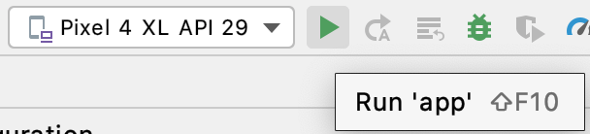

Be patient, the emulator may take a few minutes to load.

If the app launches and doesn’t crash -- great! You are done. Apparently the changes you made to the app did not have an effect on the data being stored.

If it does crash -- don’t worry. A message will appear

to inform you that the app has crashed. Click **OK**.

Then, swipe up and find the Sharing **App. Long click** on the icon to see the **App info**

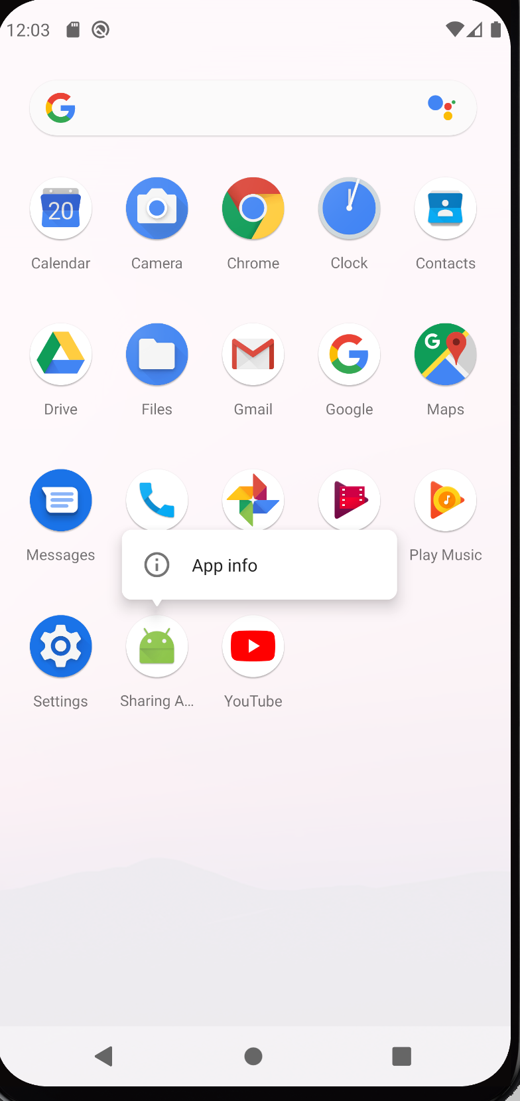

Click **App Info,** and then select **Uninstall**

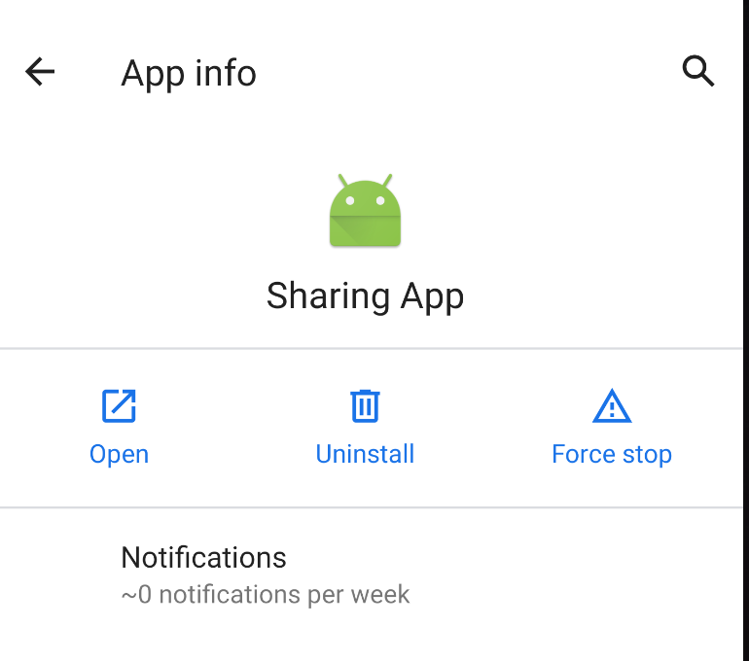

Now the app is uninstalled and all the previously stored data has been erased. The next time you run your app it shouldn’t crash… unless you have a different error.

### **Add a Menu**

Locate the **res** folder in the project.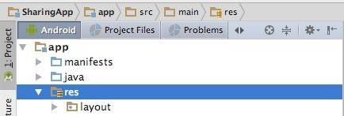

Add a **menu** folder to the **res** folder by right clicking on the **res** folder, then clicking **New** -> **Directory**

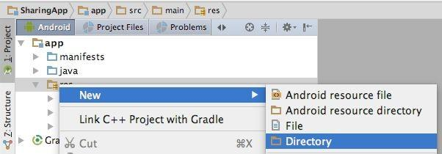

Name the directory **menu**. Hit **Enter**: 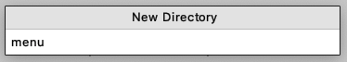

Add a menu resource file to the **menu** folder by right clicking on the **menu** folder, then clicking **New → Menu resource file**.

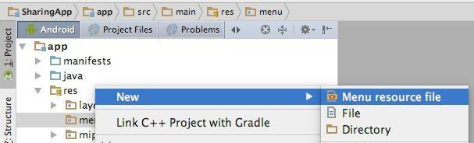

Call the resource file **menu_main.xml**. Click **OK**.

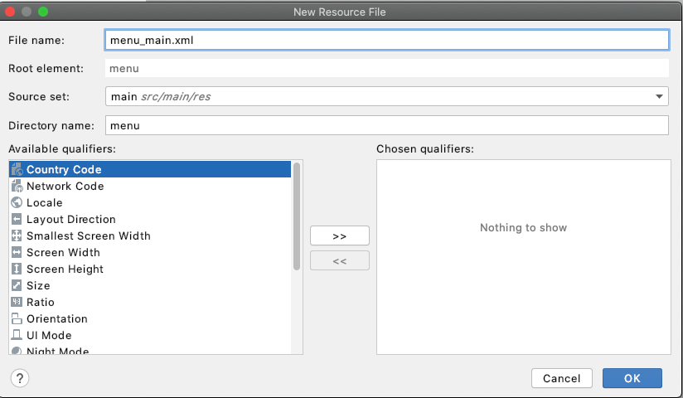

The **menu_main.xml** will be displayed in **Design** mode.

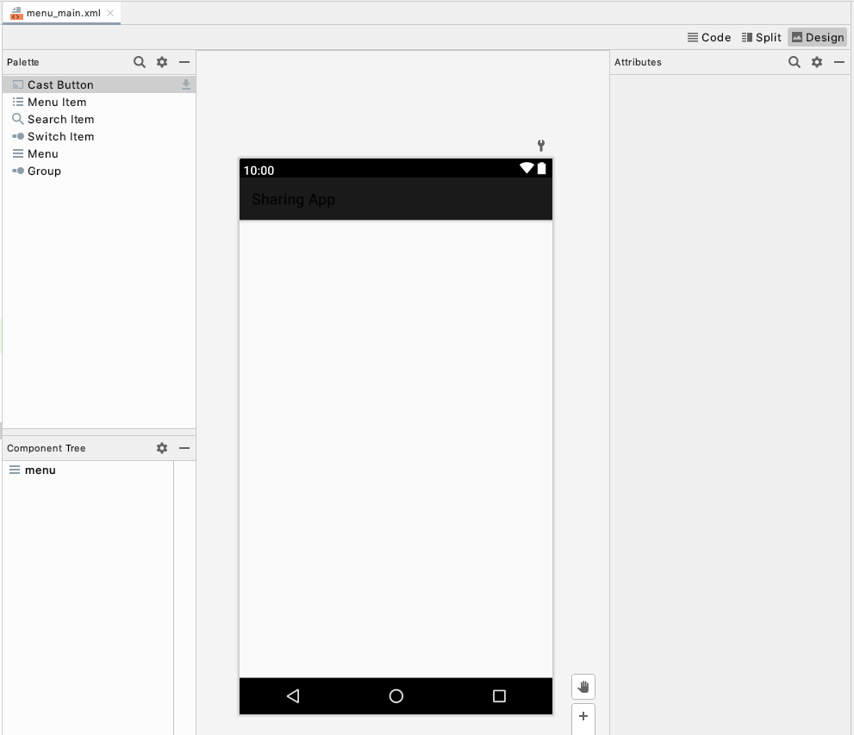

However, we want to work in **Code** mode. To switch modes click the Text tab near the bottom of the screen.

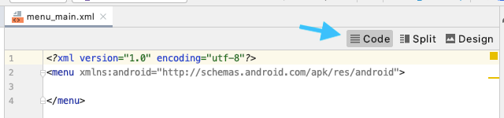

To implement the menu resource file replace contents of **menu_main.xml** with:

*<?***xml version="1.0" encoding="utf-8"***?>*

<**menu xmlns:android="http://schemas.android.com/apk/res/android"**

**xmlns:tools="http://schemas.android.com/tools"**

**tools:context="com.example.sharingapp.MainActivity"**>

<**item**

**android:id="@+id/contacts"**

**android:title="@string/contacts"** />

</**menu**>

Next, locate **MainActivity** within the project. Double click on **MainActivity** to open it.

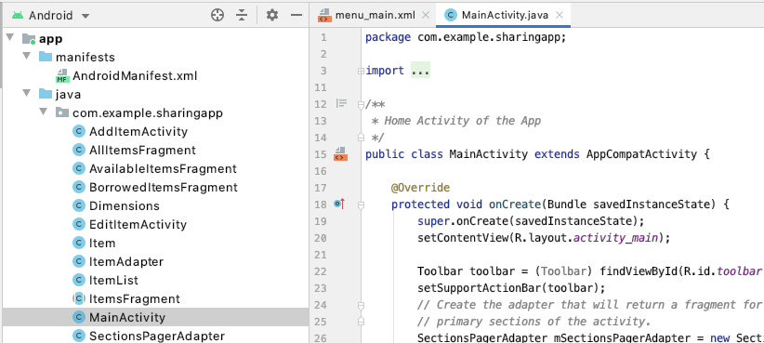

Add two new imports:

**import** android.view.Menu;

**import** android.view.MenuItem;

We need to add the following two methods to **MainActivity:**

* **onCreateOptionsMenu()**: called when **MainActivity** is started. This method links the menu resource file **menu_main.xml** to **MainActivity** and “inflates” the menu.
* **onOptionsItemSelected()**: called when the user selects an option from the menu. In this application, this code handles what happens when the user selects the “Contacts” option from the menu -- **ContactsActivity** is started.

@Override

**public boolean** onCreateOptionsMenu(Menu menu) {

*// Inflate the menu; this adds items to the action bar if it is present.*

getMenuInflater().inflate(R.menu.***menu_main***, menu);*//Menu Resource, Menu*

**return true**;

}

@Override

**public boolean** onOptionsItemSelected(MenuItem item) {

**switch** (item.getItemId()) {

**case** R.id.***contacts***:

Intent intent = **new** Intent(**this**, ContactsActivity.**class**);

startActivity(intent);

**return true**;

**default**:

**return super**.onOptionsItemSelected(item);

}

}

Notice that **ContactsActivity.class** is in **red**. This is because we have not created a **ContactsActivity** class yet. This error will disappear in the next part of the tutorial when we create the **ContactsActivity** class.

### **Create the ContactsActivity Class**

Right click on the **com.example.sharingapp** folder, then click **New → Activity → Empty Activity**.

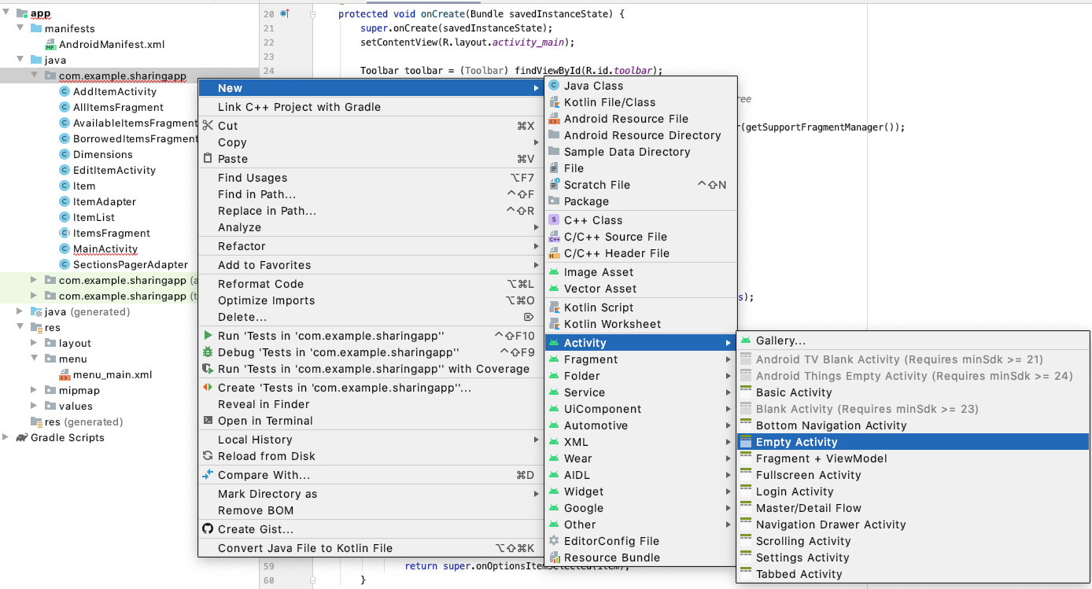

Name the activity **ContactsActivity** and the resource file **activity_contacts**. Then click

**Finish**.

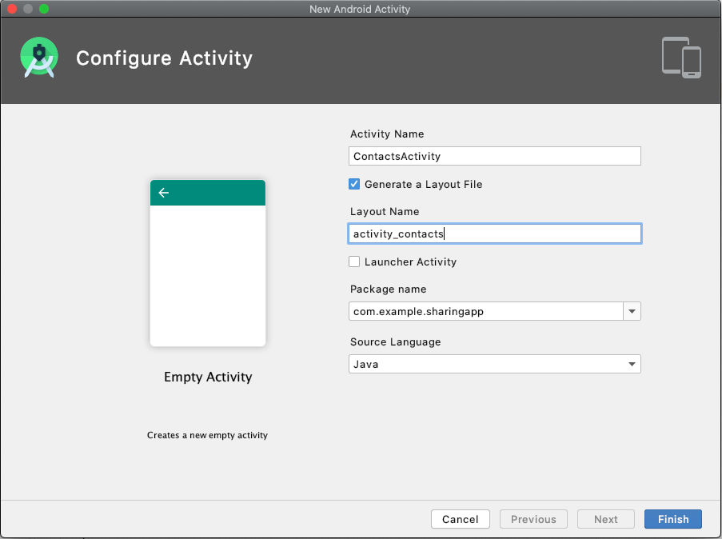

As a result:

* + A new layout resource in the **layout** folder called **activity_contacts.xml** is created.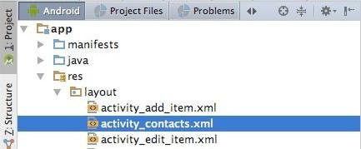
  + A new activity class called **ContactsActivity** is created.

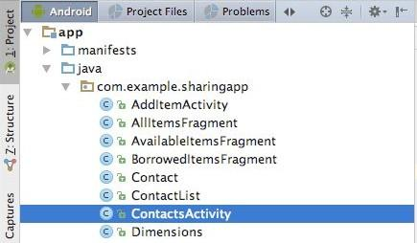

* + You can also see that in **AndroidManifest.xml** file:

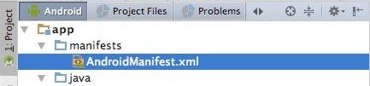

the line



is **automatically added** to the **AndroidManifest.xml** file to link **ContactsActivity** to all the other activities in the app.

### **Implement the ContactsActivity Layout Resource File, activity_contacts.xml**

In the previous step we created **activity_contacts.xml**, the layout resource file corresponding to **ContactsActivity**.

The user stories explain that **ContactsActivity** will display a list of contacts. To achieve this we need to update the resource file, **activity_contacts.xml**, to add an ImageButton, which when clicked will start **ContactsActivity**.

Replace the current contents of **activity_contacts.xml** with:

*<?***xml version="1.0" encoding="utf-8"***?>*

<**LinearLayout xmlns:android="http://schemas.android.com/apk/res/android"**

**android:orientation="vertical"**

**android:layout_width="match_parent"**

**android:layout_height="match_parent"**

**android:paddingBottom="16dp"**

**android:paddingLeft="16dp"**

**android:paddingRight="16dp"**

**android:paddingTop="16dp"**

**xmlns:app="http://schemas.android.com/apk/res-auto"**

**xmlns:tools="http://schemas.android.com/tools"**

**tools:context="com.example.sharingapp.ContactsActivity"**>

<**ImageButton**

**android:id="@+id/imageButton"**

**android:layout_width="wrap_content"**

**android:layout_height="wrap_content"**

**android:layout_gravity="end"**

**android:onClick="addContactActivity"**

**android:background="@color/colorPrimary"**

**app:srcCompat="@android:drawable/ic_input_add"**

**tools:layout_editor_absoluteX="8dp"**

**tools:layout_editor_absoluteY="0dp"** />

<**ListView**

**android:id="@+id/my_contacts"**

**android:layout_width="match_parent"**

**android:layout_height="wrap_content"**

**tools:layout_editor_absoluteX="8dp"**

**tools:layout_editor_absoluteY="75dp"** />

</**LinearLayout**>

Note that since we haven’t implemented the “onClick” method, it will remain red until we complete it.

### **Create and Implement a Layout Resource for a Contact Display in the List of Contacts: contactlist_contact.xml**

Recall the user stories explain that **ContactsActivity** will display a list of contacts.

Each contact that appears in the list will display the same information: username and email address. Each contact displayed will make use of the same layout resource file. We can create this resource file by right clicking on the **layout** folder:

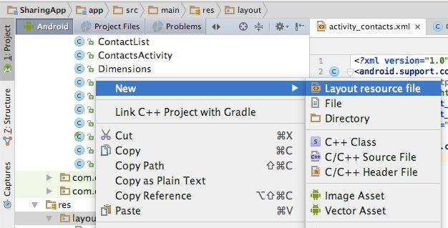

Name this new resource **contactlist_contact**. Click **OK**.

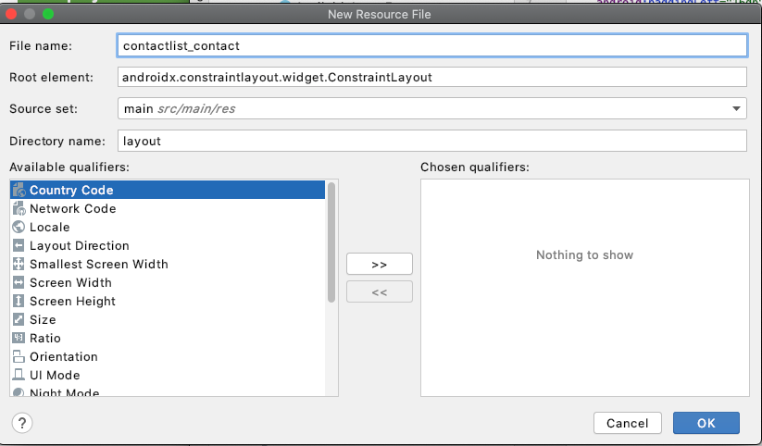

After clicking **OK**, this opens the **contactlist_contact.xml** resource in **Design** mode.

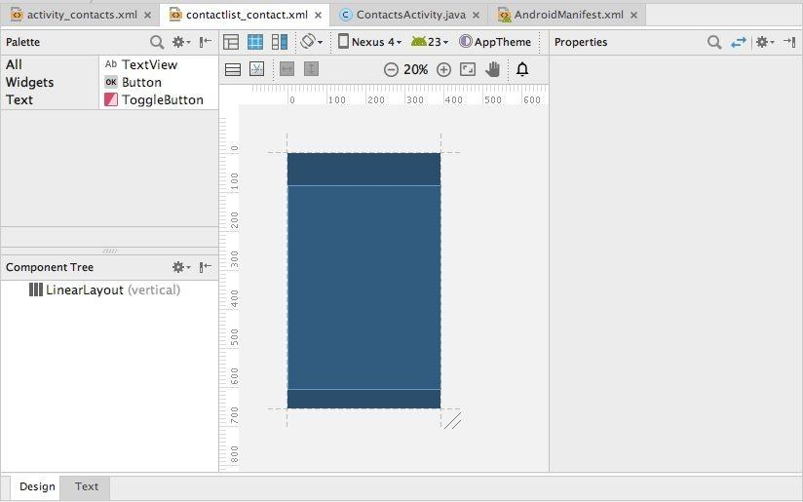

To edit this file we need to click the **code** tab.

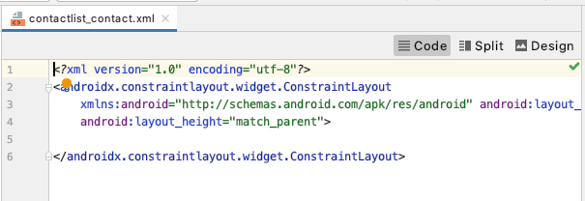

Now we replace the original contents of **contactlist_contact.xml** with the following. This code specifies how each contact will look, including which properties will be visible, how they will appear and where they will appear.

***<?*xml version="1.0" encoding="utf-8"*?>***

**<LinearLayout xmlns:android="http://schemas.android.com/apk/res/android"**

**android:layout_width="match_parent"**

**android:layout_height="wrap_content"**

**android:orientation="vertical">**

**<LinearLayout**

**android:orientation="horizontal"**

**android:layout_width="fill_parent"**

**android:layout_height="fill_parent"**

**android:layout_gravity="center_horizontal">**

**<ImageView**

**android:id="@+id/contacts_image_view"**

**android:layout_width="60dp"**

**android:layout_height="60dp"**

**android:scaleType="centerCrop"**

**android:layout_marginBottom="5dp"**

**android:layout_marginLeft="5dp"**

**android:layout_marginRight="10dp"**

**android:layout_marginTop="5dp"**

**android:background="@color/colorPrimary"**

**android:label="@string/image_icon"/>**

**<LinearLayout**

**android:orientation="vertical"**

**android:layout_width="fill_parent"**

**android:layout_height="fill_parent"**

**android:layout_gravity="center_horizontal">**

**<TextView**

**android:id="@+id/username_tv"**

**android:layout_marginTop="10dp"**

**android:layout_width="wrap_content"**

**android:layout_height="wrap_content"**

**android:hint="@string/title_hint"/>**

**<TextView**

**android:id="@+id/email_tv"**

**android:layout_width="wrap_content"**

**android:layout_height="wrap_content"**

**android:hint="@string/status_hint"/>**

**</LinearLayout>**

**</LinearLayout>**

**</LinearLayout>**

### **Create and Implement the ContactAdapter Class**

Now that we have our layout resource file for each contact that will appear in the contact list, we need to link this **contactlist_contact.xml** to the **Contact** model using a custom adapter: **ContactAdapter**.

Create the new **ContactAdapter** class by right clicking on the **com.example.sharingapp**

folder and selecting **New → Java Class**.

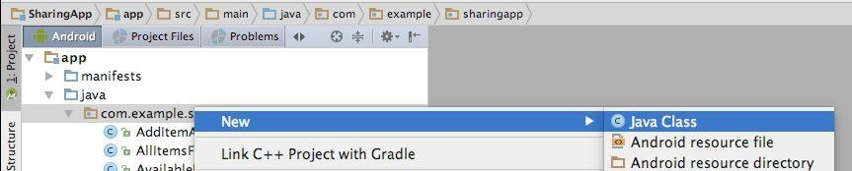

Name the new class **ContactAdapter**. Click **OK**.

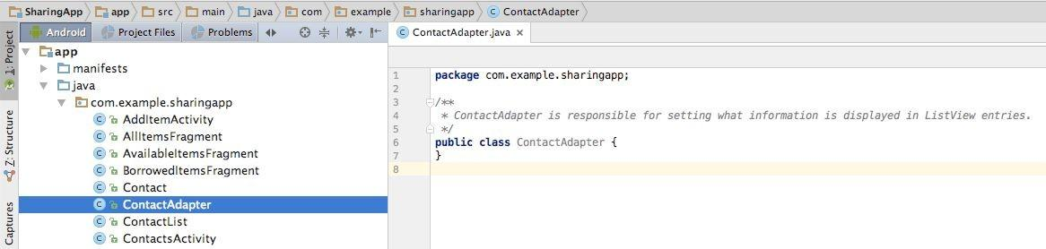

Replace the contents of **ContactAdapter** with the following code (continues onto next page):

**package** com.example.sharingapp;

**import** android.content.Context;

**import** android.view.LayoutInflater;

**import** android.view.View;

**import** android.view.ViewGroup;

**import** android.widget.ArrayAdapter;

**import** android.widget.ImageView;

**import** android.widget.TextView;

**import** java.util.ArrayList;

*/\*\**

*\* ContactAdapter is responsible for what information is displayed in ListView entries.*

*\*/*

**public class** ContactAdapter **extends** ArrayAdapter<Contact> {

**private** LayoutInflater **inflater**;

**private** Context **context**;

**public** ContactAdapter(Context context, ArrayList<Contact> contacts) {

**super**(context, 0, contacts);

**this**.**context** = context;

**this**.**inflater** = LayoutInflater.*from*(context);

}

@Override

**public** View getView(**int** position, View convertView, ViewGroup parent) {

*// getItem(position) gets the "contact" at "position" in the "contacts" ArrayList*

*// (where "contacts" is a parameter in the ContactAdapter creator as seen above ^^)*

Contact contact = getItem(position);

String username = **"Username: "** + contact.getUsername();

String email = **"Email: "** + contact.getEmail();

*// Check if an existing view is being reused, otherwise inflate the view.*

**if** (convertView == **null**) {

convertView = **inflater**.*from*(**context**).inflate(R.layout.***contactlist_contact***, parent, **false**);

}

TextView username_tv = (TextView) convertView.findViewById(R.id.***username_tv***);

TextView email_tv = (TextView) convertView.findViewById(R.id.***email_tv***);

ImageView photo = (ImageView) convertView.findViewById(R.id.***contacts_image_view***);

photo.setImageResource(android.R.drawable.***ic_menu_gallery***);

username_tv.setText(username);

email_tv.setText(email);

**return** convertView;

}

}

Alternatively, you can also use the [content of this gist](https://gist.github.com/Aquafina99/cd0cb2c7ff52f0d75dae4a9cb6f8c5ff)to copy the code**.**

Notice that everything related to the **Contact** model is shown in **red**. Don’t worry about this now. When you create and implement the **Contact** and **ContactList** classes these errors should go away.

### **Implement the ContactsActivity Class**

Now that we have our contact list related layout resources in place, we can flesh out **ContactsActivity**. Double click on the **ContactsActivity** class to open it. Replace the contents of the file with the following code (continues onto next page):

**package** com.example.sharingapp;

**import** android.content.Context;

**import** android.content.Intent;

**import** android.os.Bundle;

**import** androidx.appcompat.app.AppCompatActivity;

**import** android.view.View;

**import** android.widget.AdapterView;

**import** android.widget.ArrayAdapter;

**import** android.widget.ListView;

**import** android.widget.Toast;

**import** java.util.ArrayList;

*/\*\**

*\* Displays a list of all contacts*

*\*/*

**public class** ContactsActivity **extends** AppCompatActivity {

**private** ContactList **contact_list** = **new** ContactList();

**private** ListView **my_contacts**;

**private** ArrayAdapter<Contact> **adapter**;

**private** Context **context**;

**private** ItemList **item_list** = **new** ItemList();

**private** ContactList **active_borrowers_list** = **new** ContactList();

**protected void** onCreate(Bundle savedInstanceState) {

**super**.onCreate(savedInstanceState);

setContentView(R.layout.***activity_contacts***);

**context** = getApplicationContext();

**contact_list**.loadContacts(**context**);

**item_list**.loadItems(**context**);

**my_contacts** = (ListView) findViewById(R.id.***my_contacts***);

**adapter** = **new** ContactAdapter(ContactsActivity.**this**, **contact_list**.getContacts());

**my_contacts**.setAdapter(**adapter**);

**adapter**.notifyDataSetChanged();

*// When contact is long clicked, this starts EditContactActivity*

**my_contacts**.setOnItemLongClickListener(**new** android.widget.AdapterView.OnItemLongClickListener() {

@Override

**public boolean** onItemLongClick(AdapterView<?> parent, View view, **int** pos, **long** id) {

Contact contact = **adapter**.getItem(pos);

ArrayList<Contact> active_borrowers = **item_list**.getActiveBorrowers();

**active_borrowers_list**.setContacts(active_borrowers);

*// Prevent contact from editing an "active" borrower.*

**if** (**active_borrowers_list** != **null**) {

**if** (**active_borrowers_list**.hasContact(contact)) {

CharSequence text = **"Cannot edit or delete active borrower!"**;

**int** duration = Toast.***LENGTH_SHORT***;

Toast.*makeText*(**context**, text, duration).show();

**return true**;

}

}

**contact_list**.loadContacts(**context**); *// Must load contacts again here*

**int** meta_pos = **contact_list**.getIndex(contact);

Intent intent = **new** Intent(**context**, EditContactActivity.**class**);

intent.putExtra(**"position"**, meta_pos);

startActivity(intent);

**return true**;

}

});

}

@Override

**protected void** onStart() {

**super**.onStart();

**context** = getApplicationContext();

**contact_list**.loadContacts(**context**);

**my_contacts** = (ListView) findViewById(R.id.***my_contacts***);

**adapter** = **new** ContactAdapter(ContactsActivity.**this**, **contact_list**.getContacts());

**my_contacts**.setAdapter(**adapter**);

**adapter**.notifyDataSetChanged();

}

**public void** addContactActivity(View view){

Intent intent = **new** Intent(**this**, AddContactActivity.**class**);

startActivity(intent);

}

}

Alternatively, you can also use the [content of this gist](https://gist.github.com/Aquafina99/f6c13a9e2a615b3e8645266ce9ae33a6) to copy the code.

Notice that everything related to the **Contact** model and **ContactList** class is shown in **red**. Don’t worry about this now. When you create and implement the **Contact** and **ContactList** classes these errors should go away. However, there are also some additional errors here that are not directly related to this, we will deal with them shortly.

### **Update the Item Class**

Next we need to update the **Item** class. Double click on the **Item** class to edit the file. In the original app, the borrower was stored as a **String**:

**private** String **borrower**;

However, the updated UML class diagram indicates that the borrower should be stored as a

**Contact**. This means we need to replace the above line of code to:

**private** Contact **borrower**;

This change in type (from **String** to **Contact**) requires that several **Item** methods are updated. Replace the **Item()**, **setBorrower()** and **getBorrower()** methods with the following:

**public** Item(String title, String maker, String description, Dimensions dimensions, Bitmap image,

String id) {

**this**.**title** = title;

**this**.**maker** = maker;

**this**.**description** = description;

**this**.**dimensions** = dimensions;

**this**.**status** = **"Available"**;

**this**.**borrower** = **null**;

addImage(image);

**if** (id == **null**){

setId();

} **else** {

updateId(id);

}

}

**public void** setBorrower(Contact borrower) {

**this**.**borrower** = borrower;

}

**public** Contact getBorrower() {

**return borrower**;

}

Notice that everything related to the **Contact** model is shown in red. Don’t worry about this now. When you create and implement the **Contact** and **ContactList** classes these errors should go away.

### **Update the ItemList Class**

According to the updated UML class diagram we need to implement a new method in

**ItemList**, **getActiveBorrowers()**. Double click on the **ItemList** class to edit the file. Add the following method to the **ItemList** class:

**public** ArrayList<Contact> getActiveBorrowers() {

ArrayList<Contact> active_borrowers = **new** ArrayList<Contact>();

**for** (Item i : *items*) {

Contact borrower = i.getBorrower();

**if** (borrower != **null**) {

active_borrowers.add(borrower);

}

}

**return** active_borrowers;

}

Notice that everything related to the **Contact** model is shown in red. Don’t worry about this now. When you create and implement the **Contact** and **ContactList** classes these errors should go away.

### **Create the AddContactActivity Class**

Right click on the com.example.sharingapp folder then click **New** → **Activity** → **Empty Activity**.

Name the activity **AddContactActivity** and the resource file **activity_add_contact**. Then click **Finish**.

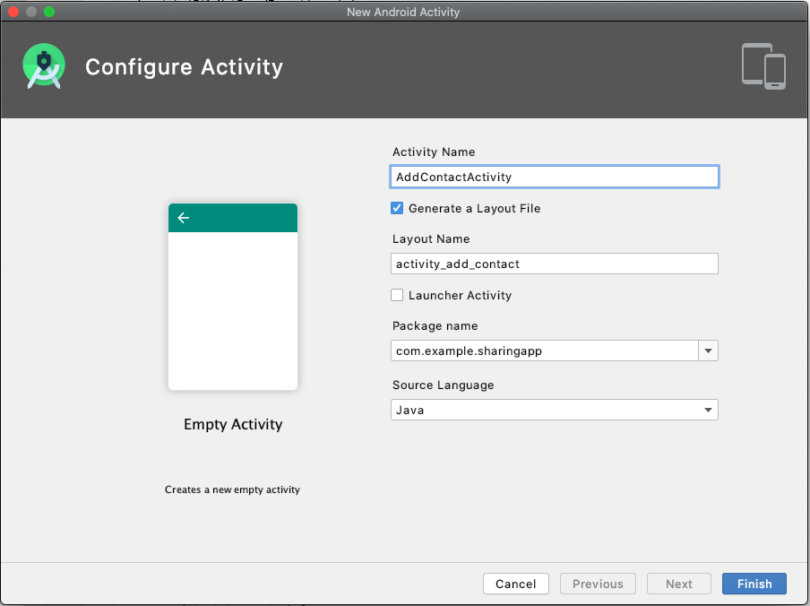

As a result:

* + A new layout resource in the **layout** folder called **activity_add_contact.xml** is created. We will take a closer look at **activity_add_contact.xml** soon.
  + A new activity class called **AddContactActivity** is created. We will revisit

**AddContactActivity** later in the tutorial.

* + And the line

<**activity android:name=".AddContactActivity"** />

is automatically added to the **AndroidManifest.xml** file to link **AddContactActivity** to all the other activities in the app

### **Implement the AddContactActivity Layout Resource File, activity_add_contact.xml**

In the previous step we created **activity_add_contact.xml**, the layout resource file corresponding to **AddContactActivity**.

Next, we need to replace the current contents of **activity_add_contact.xml** with the following code (continues onto next page):

*<?***xml version="1.0" encoding="utf-8"***?>*

<**LinearLayout xmlns:android="http://schemas.android.com/apk/res/android"**

**xmlns:tools="http://schemas.android.com/tools"**

**android:layout_width="match_parent"**

**android:layout_height="match_parent"**

**android:paddingBottom="16dp"**

**android:paddingLeft="16dp"**

**android:paddingRight="16dp"**

**android:paddingTop="16dp"**

**tools:context="com.example.sharingapp.AddContactActivity"**

**android:orientation="vertical"**>

<**LinearLayout**

**android:orientation="horizontal"**

**android:layout_width="fill_parent"**

**android:layout_height="wrap_content"**

**android:layout_gravity="center_horizontal"**

**android:layout_marginTop="5dp"**>

<**TextView**

**android:id="@+id/username_tv"**

**android:layout_width="104dp"**

**android:layout_height="wrap_content"**

**android:text="@string/username_hint"**

**android:gravity="center_vertical"**

**android:textAppearance="@android:style/TextAppearance.Medium"** />

<**EditText**

**android:id="@+id/username"**

**android:layout_width="fill_parent"**

**android:layout_height="wrap_content"**

**android:hint="@string/username_hint"**

**android:inputType="text"**

**android:textAppearance="@android:style/TextAppearance.Medium"**

**android:maxLength="24"**/>

</**LinearLayout**>

<**LinearLayout**

**android:orientation="horizontal"**

**android:layout_width="fill_parent"**

**android:layout_gravity="center"**

**android:layout_height="wrap_content"**

**android:layout_marginTop="5dp"**>

<**TextView**

**android:id="@+id/email_tv"**

**android:layout_width="104dp"**

**android:layout_height="wrap_content"**

**android:text="@string/email_hint"**

**android:gravity="center_vertical"**

**android:textAppearance="@android:style/TextAppearance.Medium"** />

<**EditText**

**android:id="@+id/email"**

**android:layout_width="fill_parent"**

**android:layout_height="wrap_content"**

**android:hint="@string/email_hint"**

**android:inputType="textEmailAddress"**

**android:textAppearance="@android:style/TextAppearance.Medium"**

**android:maxLength="24"**/>

</**LinearLayout**>

<**LinearLayout**

**android:orientation="horizontal"**

**android:layout_width="fill_parent"**

**android:layout_gravity="center"**

**android:layout_height="wrap_content"**

**android:layout_marginTop="5dp"**>

<**Button**

**android:id="@+id/save_button"**

**android:layout_width="0dp"**

**android:layout_height="wrap_content"**

**android:layout_weight="0.25"**

**android:onClick="saveContact"**

**android:text="@string/save"**

**android:layout_gravity="center_horizontal"**

**android:textAppearance="@android:style/TextAppearance.Medium"**/>

</**LinearLayout**>

</**LinearLayout**>

Alternatively, you can also use [the content of this gist](https://gist.github.com/Aquafina99/65adaa83ec8116b6b311624ee9d64d47) to copy the content. Note that since we haven’t implemented the “onClick” method, it will remain red until we complete it.

### **Implement the AddContactActivity Class**

Now that we have its corresponding layout resource in place, we can flesh out

**AddContactActivity**.

Double click on the **AddContactActivity** class to open it. Replace the contents of the file with following code (continues onto next page):

**package** com.example.sharingapp;

**import** android.content.Context;

**import** androidx.appcompat.app.AppCompatActivity**;**

**import** android.os.Bundle;

**import** android.view.View;

**import** android.widget.EditText;

*/\*\**

*\* Add a new contact*

*\*/*

**public class** AddContactActivity **extends** AppCompatActivity {

**private** ContactList **contact_list** = **new** ContactList();

**private** Context **context**;

**private** EditText **username**;

**private** EditText **email**;

@Override

**protected void** onCreate(Bundle savedInstanceState) {

**super**.onCreate(savedInstanceState);

setContentView(R.layout.***activity_add_contact***);

**username** = (EditText) findViewById(R.id.***username***);

**email** = (EditText) findViewById(R.id.***email***);

**context** = getApplicationContext();

**contact_list**.loadContacts(**context**);

}

**public void** saveContact(View view) {

String username_str = **username**.getText().toString();

String email_str = **email**.getText().toString();

**if** (username_str.equals(**""**)) {

**username**.setError(**"Empty field!"**);

**return**;

}

**if** (email_str.equals(**""**)) {

**email**.setError(**"Empty field!"**);

**return**;

}

**if** (!email_str.contains(**"@"**)){

**email**.setError(**"Must be an email address!"**);

**return**;

}

**if** (!**contact_list**.isUsernameAvailable(username_str)){

**username**.setError(**"Username already taken!"**);

**return**;

}

Contact contact = **new** Contact(username_str, email_str, **null**);

**contact_list**.addContact(contact);

**contact_list**.saveContacts(**context**);

*// End AddContactActivity*

finish();

}

}

Alternatively, you can also use [the content of this gist](https://gist.github.com/Aquafina99/4cf584154731dc516d832149697dfdc5) to copy the code.

Notice that everything related to the **Contact** model or **ContactList** is shown in **red**. Don’t worry about this now. When you create and implement the **Contact** and **ContactList** classes these errors should go away.

### **Create the EditContactActivity Class**

Next, we will create the **EditContactActivity**. Right click on the **com.example.sharingapp**

folder then click **New** → **Activity** → **Empty Activity**

Name the activity **EditContactActivity** and the resource file **activity_edit_contact**. Then click **Finish**.

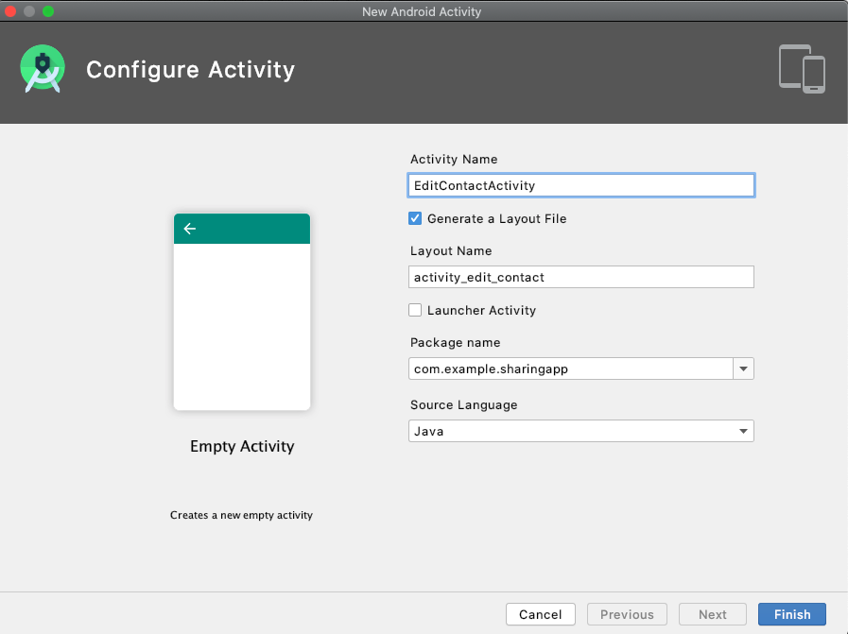

As a result:

* + A new layout resource in the layout folder called **activity_edit_contact.xml** is created. We will take a closer look at **activity_edit_contact.xml** soon.
  + A new activity class called **EditContactActivity** is created. We will revisit

**EditContactActivity** later in the tutorial.

And the line:

<**activity android:name=".EditContactActivity"** />

is automatically added to the AndroidManifest.xml file to link **EditContactActivity** to all the other activities in the app.

### **Implement the EditContactActivity layout resource file, activity_edit_contact.xml**

In the previous step we created **activity_edit_contact.xml**, the layout resource file corresponding to **EditContactActivity**. Replace the current contents of **activity_edit_contacts.xml** with the following code (continues onto next page):

*<?***xml version="1.0" encoding="utf-8"***?>*

<**LinearLayout xmlns:android="http://schemas.android.com/apk/res/android"**

**xmlns:tools="http://schemas.android.com/tools"**

**android:layout_width="match_parent"**

**android:layout_height="match_parent"**

**android:paddingBottom="16dp"**

**android:paddingLeft="16dp"**

**android:paddingRight="16dp"**

**android:paddingTop="16dp"**

**tools:context="com.example.sharingapp.EditContactActivity"**

**android:orientation="vertical"**>

<**LinearLayout**

**android:orientation="horizontal"**

**android:layout_width="fill_parent"**

**android:layout_height="wrap_content"**

**android:layout_gravity="center_horizontal"**

**android:layout_marginTop="5dp"**>

<**TextView**

**android:id="@+id/username_tv"**

**android:layout_width="104dp"**

**android:layout_height="wrap_content"**

**android:gravity="center_vertical"**

**android:text="@string/username_hint"**

**android:textAppearance="@android:style/TextAppearance.Medium"** />

<**EditText**

**android:id="@+id/username"**

**android:layout_width="fill_parent"**

**android:layout_height="wrap_content"**

**android:hint="@string/title_hint"**

**android:inputType="text"**

**android:textAppearance="@android:style/TextAppearance.Medium"**

**android:maxLength="24"**/>

</**LinearLayout**>

<**LinearLayout**

**android:orientation="horizontal"**

**android:layout_width="fill_parent"**

**android:layout_gravity="center"**

**android:layout_height="wrap_content"**

**android:layout_marginTop="5dp"**>

<**TextView**

**android:id="@+id/email_tv"**

**android:layout_width="104dp"**

**android:layout_height="wrap_content"**

**android:gravity="center_vertical"**

**android:text="@string/email_hint"**

**android:textAppearance="@android:style/TextAppearance.Medium"** />

<**EditText**

**android:id="@+id/email"**

**android:layout_width="fill_parent"**

**android:layout_height="wrap_content"**

**android:hint="@string/email_hint"**

**android:inputType="textEmailAddress"**

**android:maxLength="24"**

**android:textAppearance="@android:style/TextAppearance.Medium"** />

</**LinearLayout**>

<**LinearLayout**

**android:orientation="horizontal"**

**android:layout_width="fill_parent"**

**android:layout_gravity="center"**

**android:layout_height="wrap_content"**

**android:layout_marginTop="5dp"**>

<**Button**

**android:id="@+id/save_edited_user_button"**

**android:layout_width="0dp"**

**android:layout_height="wrap_content"**

**android:layout_gravity="center_horizontal"**

**android:layout_weight="0.25"**

**android:onClick="saveContact"**

**android:text="@string/save"**

**android:textAppearance="@android:style/TextAppearance.Medium"** />

<**Button**

**android:id="@+id/delete_edited_user_button"**

**android:layout_width="0dp"**

**android:layout_height="wrap_content"**

**android:layout_gravity="center_horizontal"**

**android:layout_weight="0.25"**

**android:onClick="deleteContact"**

**android:text="@string/delete"**

**android:textAppearance="@android:style/TextAppearance.Medium"** />

</**LinearLayout**>

</**LinearLayout**>

Alternatively, you can also use the [content of this gist](https://gist.github.com/Aquafina99/f28c22e1437cc9045b108bf533587b61) to copy the code. Note that since we haven’t implemented the “onClick” methods, they will remain red until we complete them.

### **Implement the EditContactActivity Class**

Now that we have its corresponding layout resource in place, we can flesh out

**EditContactActivity**.

Double click on the **EditContactActivity** class to open it. Replace the contents of the file with the following (continues onto next page):

**package** com.example.sharingapp;

**import** android.content.Context;

**import** android.content.Intent;

**import** androidx.appcompat.app.AppCompatActivity;

**import** android.os.Bundle;

**import** android.view.View;

**import** android.widget.EditText;

*/\*\**

*\* Editing a pre-existing contact consists of deleting the old contact and adding a new contact with the old*

*\* contact's id.*

*\* Note: You will not be able contacts which are "active" borrowers*

*\*/*

**public class** EditContactActivity **extends** AppCompatActivity {

**private** ContactList **contact_list** = **new** ContactList();

**private** Contact **contact**;

**private** EditText **email**;

**private** EditText **username**;

**private** Context **context**;

@Override

**protected void** onCreate(Bundle savedInstanceState) {

**super**.onCreate(savedInstanceState);

setContentView(R.layout.***activity_edit_contact***);

**context** = getApplicationContext();

**contact_list**.loadContacts(**context**);

Intent intent = getIntent();

**int** pos = intent.getIntExtra(**"position"**, 0);

**contact** = **contact_list**.getContact(pos);

**username** = (EditText) findViewById(R.id.***username***);

**email** = (EditText) findViewById(R.id.***email***);

**username**.setText(**contact**.getUsername());

**email**.setText(**contact**.getEmail());

}

**public void** saveContact(View view) {

String email_str = **email**.getText().toString();

**if** (email_str.equals(**""**)) {

**email**.setError(**"Empty field!"**);

**return**;

}

**if** (!email_str.contains(**"@"**)){

**email**.setError(**"Must be an email address!"**);

**return**;

}

String username_str = **username**.getText().toString();

String id = **contact**.getId(); *// Reuse the contact id*

*// Check that username is unique AND username is changed (Note: if username was not changed*

*// then this should be fine, because it was already unique.)*

**if** (!**contact_list**.isUsernameAvailable(username_str) && !(**contact**.getUsername().equals(username_str))) {

**username**.setError(**"Username already taken!"**);

**return**;

}

Contact updated_contact = **new** Contact(username_str, email_str, id);

**contact_list**.deleteContact(**contact**);

**contact_list**.addContact(updated_contact);

**contact_list**.saveContacts(**context**);

*// End EditContactActivity*

finish();

}

**public void** deleteContact(View view) {

**contact_list**.deleteContact(**contact**);

**contact_list**.saveContacts(**context**);

*// End EditContactActivity*

finish();

}

}

Alternatively, you can also use the [content of this gist](https://gist.github.com/Aquafina99/72b3cc084b06bb88ebfb1fac7327fe04) to copy the code.

Notice that everything related to the **Contact** model or **ContactList** class is shown in **red**. Don’t worry about this now. When you create and implement the **Contact** and **ContactList** classes these errors should go away

### **Update the EditItemActivity Class**

Because changes were made to the **ItemList** model to store the borrower as a Contact now, instead of as a String, we need to update **EditItemActivity**.

Double click on **EditItemActivity** to edit the file. Replace the current contents of

**EditItemActivity** with the following code (continues on several pages):

**package** com.example.sharingapp;

**import** android.content.Context;

**import** android.content.Intent;

**import** android.graphics.Bitmap;

**import** android.provider.MediaStore;

**import** androidx.appcompat.app.AppCompatActivity**;**

**import** android.os.Bundle;

**import** android.view.View;

**import** android.widget.ArrayAdapter;

**import** android.widget.EditText;

**import** android.widget.ImageView;

**import** android.widget.Spinner;

**import** android.widget.Switch;

**import** android.widget.TextView;

*/\*\**

*\* Editing a pre-existing item consists of deleting the old item and adding a new item with the old*

*\* item's id.*

*\* Note: invisible EditText is used to setError for status. For whatever reason we cannot .setError to*

*\* the status Switch so instead an error is set to an "invisible" EditText.*

*\*/*

**public class** EditItemActivity **extends** AppCompatActivity{

**private** ItemList **item_list** = **new** ItemList();

**private** Item **item**;

**private** Context **context**;

**private** ContactList **contact_list** = **new** ContactList();

**private** Bitmap **image**;

**private int REQUEST_CODE** = 1;

**private** ImageView **photo**;

**private** EditText **title**;

**private** EditText **maker**;

**private** EditText **description**;

**private** EditText **length**;

**private** EditText **width**;

**private** EditText **height**;

**private** Spinner **borrower_spinner**;

**private** TextView **borrower_tv**;

**private** Switch **status**;

**private** EditText **invisible**;

@Override

**protected void** onCreate(Bundle savedInstanceState) {

**super**.onCreate(savedInstanceState);

setContentView(R.layout.***activity_edit_item***);

**title** = (EditText) findViewById(R.id.***title***);

**maker** = (EditText) findViewById(R.id.***maker***);

**description** = (EditText) findViewById(R.id.***description***);

**length** = (EditText) findViewById(R.id.***length***);

**width** = (EditText) findViewById(R.id.***width***);

**height** = (EditText) findViewById(R.id.***height***);

**borrower_spinner** = (Spinner) findViewById(R.id.***borrower_spinner***);

**borrower_tv** = (TextView) findViewById(R.id.***borrower_tv***);

**photo** = (ImageView) findViewById(R.id.***image_view***);

**status** = (Switch) findViewById(R.id.***available_switch***);

**invisible** = (EditText) findViewById(R.id.***invisible***);

**invisible**.setVisibility(View.***GONE***);

**context** = getApplicationContext();

**item_list**.loadItems(**context**);

**contact_list**.loadContacts(**context**);

ArrayAdapter<String> adapter = **new** ArrayAdapter<String>(**this**,

android.R.layout.***simple_spinner_dropdown_item***, **contact_list**.getAllUsernames());

**borrower_spinner**.setAdapter(adapter);

Intent intent = getIntent(); *// Get intent from ItemsFragment*

**int** pos = intent.getIntExtra(**"position"**, 0);

**item** = **item_list**.getItem(pos);

Contact contact = **item**.getBorrower();

**if** (contact != **null**){

**int** contact_pos = **contact_list**.getIndex(contact);

**borrower_spinner**.setSelection(contact_pos);

}

**title**.setText(**item**.getTitle());

**maker**.setText(**item**.getMaker());

**description**.setText(**item**.getDescription());

Dimensions dimensions = **item**.getDimensions();

**length**.setText(dimensions.getLength());

**width**.setText(dimensions.getWidth());

**height**.setText(dimensions.getHeight());

String status_str = **item**.getStatus();

**if** (status_str.equals(**"Borrowed"**)) {

**status**.setChecked(**false**);

} **else** {

**borrower_tv**.setVisibility(View.***GONE***);

**borrower_spinner**.setVisibility(View.***GONE***);

}

**image** = **item**.getImage();

**if** (**image** != **null**) {

**photo**.setImageBitmap(**image**);

} **else** {

**photo**.setImageResource(android.R.drawable.***ic_menu_gallery***);

}

}

**public void** addPhoto(View view) {

Intent intent = **new** Intent(MediaStore.***ACTION_IMAGE_CAPTURE***);

**if** (intent.resolveActivity(getPackageManager()) != **null**) {

startActivityForResult(intent, **REQUEST_CODE**);

}

}

**public void** deletePhoto(View view) {

**image** = **null**;

**photo**.setImageResource(android.R.drawable.***ic_menu_gallery***);

}

@Override

**protected void** onActivityResult(**int** request_code, **int** result_code, Intent intent){

**if** (request_code == **REQUEST_CODE** && result_code == ***RESULT_OK***){

Bundle extras = intent.getExtras();

**image** = (Bitmap) extras.get(**"data"**);

**photo**.setImageBitmap(**image**);

}

}

**public void** deleteItem(View view) {

**item_list**.deleteItem(**item**);

**item_list**.saveItems(**context**);

*// End EditItemActivity*

Intent intent = **new** Intent(**this**, MainActivity.**class**);

startActivity(intent);

}

**public void** saveItem(View view) {

String title_str = **title**.getText().toString();

String maker_str = **maker**.getText().toString();

String description_str = **description**.getText().toString();

String length_str = **length**.getText().toString();

String width_str = **width**.getText().toString();

String height_str = **height**.getText().toString();

Contact contact = **null**;

**if** (!**status**.isChecked()) {

String borrower_str = **borrower_spinner**.getSelectedItem().toString();

contact = **contact_list**.getContactByUsername(borrower_str);

}

Dimensions dimensions = **new** Dimensions(length_str, width_str, height_str);

**if** (title_str.equals(**""**)) {

**title**.setError(**"Empty field!"**);

**return**;

}

**if** (maker_str.equals(**""**)) {

**maker**.setError(**"Empty field!"**);

**return**;

}

**if** (description_str.equals(**""**)) {

**description**.setError(**"Empty field!"**);

**return**;

}

**if** (length_str.equals(**""**)) {

**length**.setError(**"Empty field!"**);

**return**;

}

**if** (width_str.equals(**""**)) {

**width**.setError(**"Empty field!"**);

**return**;

}

**if** (height_str.equals(**""**)) {

**height**.setError(**"Empty field!"**);

**return**;

}

String id = **item**.getId(); *// Reuse the item id*

Item updated_item = **new** Item(title_str, maker_str, description_str, dimensions, **image**, id);

**boolean** checked = **status**.isChecked();

**if** (!checked) {

updated_item.setStatus(**"Borrowed"**);

updated_item.setBorrower(contact);

}

**item_list**.deleteItem(**item**);

**item_list**.addItem(updated_item);

**item_list**.saveItems(**context**);

*// End EditItemActivity*

Intent intent = **new** Intent(**this**, MainActivity.**class**);

startActivity(intent);

}

*/\*\**

*\* Checked = Available*

*\* Unchecked = Borrowed*

*\*/*

**public void** toggleSwitch(View view){

**if** (**status**.isChecked()) {

*// Means was previously borrowed, switch was toggled to available*

**borrower_spinner**.setVisibility(View.***GONE***);

**borrower_tv**.setVisibility(View.***GONE***);

**item**.setBorrower(**null**);

**item**.setStatus(**"Available"**);

} **else** {

*// Means not borrowed*

**if** (**contact_list**.getSize()==0){

*// No contacts, need to add contacts to be able to add a borrower.*

**invisible**.setEnabled(**false**);

**invisible**.setVisibility(View.***VISIBLE***);

**invisible**.requestFocus();

**invisible**.setError(**"No contacts available! Must add borrower to contacts."**);

**status**.setChecked(**true**); *// Set switch to available*

} **else** {

*// Means was previously available*

**borrower_spinner**.setVisibility(View.***VISIBLE***);

**borrower_tv**.setVisibility(View.***VISIBLE***);

}

}

}

}

Alternatively, you can also use the [content of this gist](https://gist.github.com/Aquafina99/27b9bf32629b1609f0a349f13076ebae) to copy the code

Notice that everything related to the **Contact** model is shown in **red**. Don’t worry about this now. When you create and implement the **Contact** and **ContactList** classes these errors should go away. However, there are also some additional errors here that are not directly related to this.

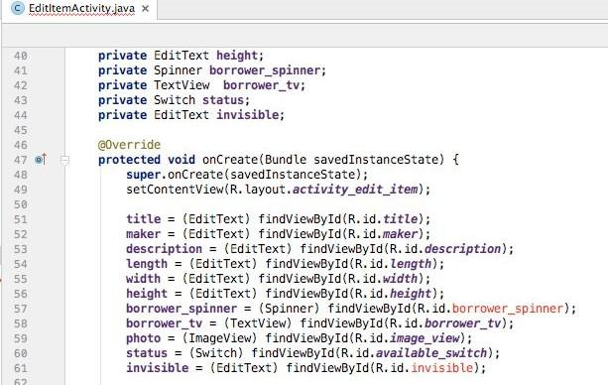

In the next step we will update **EditItemActivity**’s corresponding layout resource file to include these new layout items.

### **Update the EditItemActivity layout resource file, activity_edit_item.xml**

In the previous step we updated **EditItemActivity**. Now we need to update its corresponding layout resource file, **activity_edit_item.xml**.

Double click on **activity_edit_item** to edit the file. Replace the current contents of

**activity_edit_item.xml** with the following code (continues on several pages):

*<?***xml version="1.0" encoding="utf-8"***?>*

<**LinearLayout xmlns:android="http://schemas.android.com/apk/res/android"**

**xmlns:tools="http://schemas.android.com/tools"**

**android:layout_width="match_parent"**

**android:layout_height="match_parent"**

**android:paddingBottom="16dp"**

**android:paddingLeft="16dp"**

**android:paddingRight="16dp"**

**android:paddingTop="16dp"**

**tools:context="com.example.sharingapp.EditItemActivity"**

**android:orientation="vertical"**>

<**LinearLayout**

**android:orientation="horizontal"**

**android:layout_width="fill_parent"**

**android:layout_height="wrap_content"**

**android:layout_gravity="center_horizontal"**

**android:layout_marginTop="5dp"**>

<**TextView**

**android:id="@+id/title_tv"**

**android:layout_width="104dp"**

**android:layout_height="wrap_content"**

**android:text="@string/title_hint"**

**android:gravity="center_vertical"**

**android:textAppearance="@android:style/TextAppearance.Medium"** />

<**EditText**

**android:id="@+id/title"**

**android:layout_width="fill_parent"**

**android:layout_height="wrap_content"**

**android:hint="@string/title_hint"**

**android:inputType="text"**

**android:textAppearance="@android:style/TextAppearance.Medium"**

**android:maxLength="24"**/>

</**LinearLayout**>

<**LinearLayout**

**android:orientation="horizontal"**

**android:layout_width="fill_parent"**

**android:layout_gravity="center"**

**android:layout_height="wrap_content"**

**android:layout_marginTop="5dp"**>

<**TextView**

**android:id="@+id/maker_tv"**

**android:layout_width="104dp"**

**android:layout_height="wrap_content"**

**android:text="@string/maker_hint"**

**android:gravity="center_vertical"**

**android:textAppearance="@android:style/TextAppearance.Medium"** />

<**EditText**

**android:id="@+id/maker"**

**android:layout_width="fill_parent"**

**android:layout_height="wrap_content"**

**android:hint="@string/maker_hint"**

**android:inputType="text"**

**android:textAppearance="@android:style/TextAppearance.Medium"**

**android:maxLength="24"**/>

</**LinearLayout**>

<**LinearLayout**

**android:orientation="horizontal"**

**android:layout_width="fill_parent"**

**android:layout_gravity="center"**

**android:layout_height="wrap_content"**

**android:layout_marginTop="5dp"**>

<**TextView**

**android:id="@+id/description_tv"**

**android:layout_width="104dp"**

**android:layout_height="wrap_content"**

**android:text="@string/description_hint"**

**android:gravity="center_vertical"**

**android:textAppearance="@android:style/TextAppearance.Medium"**/>

<**EditText**

**android:id="@+id/description"**

**android:layout_width="fill_parent"**

**android:layout_height="wrap_content"**

**android:hint="@string/description_hint"**

**android:inputType="text"**

**android:textAppearance="@android:style/TextAppearance.Medium"**

**android:maxLength="24"**/>

</**LinearLayout**>

<**LinearLayout**

**android:orientation="horizontal"**

**android:layout_width="fill_parent"**

**android:layout_gravity="center"**

**android:layout_height="wrap_content"**

**android:layout_marginTop="5dp"**>

<**TextView**

**android:id="@+id/dimensions_tv"**

**android:layout_width="104dp"**

**android:layout_height="wrap_content"**

**android:text="@string/dimensions_hint"**

**android:gravity="center_vertical"**

**android:textAppearance="@android:style/TextAppearance.Medium"**/>

<**EditText**

**android:id="@+id/length"**

**android:layout_width="64dp"**

**android:layout_height="wrap_content"**

**android:hint="@string/length_hint"**

**android:inputType="numberDecimal"**

**android:textAppearance="@android:style/TextAppearance.Medium"**

**android:maxLength="24"**/>

<**EditText**

**android:id="@+id/width"**

**android:layout_width="64dp"**

**android:layout_height="wrap_content"**

**android:hint="@string/width_hint"**

**android:inputType="numberDecimal"**

**android:textAppearance="@android:style/TextAppearance.Medium"**

**android:maxLength="24"** />

<**EditText**

**android:id="@+id/height"**

**android:layout_width="64dp"**

**android:layout_height="wrap_content"**

**android:hint="@string/height_hint"**

**android:inputType="numberDecimal"**

**android:textAppearance="@android:style/TextAppearance.Medium"**

**android:maxLength="24"** />

</**LinearLayout**>

<**LinearLayout**

**android:orientation="horizontal"**

**android:layout_width="fill_parent"**

**android:layout_gravity="center"**

**android:layout_height="wrap_content"**

**android:layout_marginTop="5dp"**>

<**Switch**

**android:id="@+id/available_switch"**

**android:layout_width="wrap_content"**

**android:layout_height="wrap_content"**

**android:checked="true"**

**android:onClick="toggleSwitch"**

**android:showText="true"**

**android:text="@string/status_hint"**

**android:textAppearance="@android:style/TextAppearance.Medium"**

**android:textOff="@string/toggle_borrowed"**

**android:textOn="@string/toggle_available"** />

<**EditText**

**android:id="@+id/invisible"**

**android:layout_width="wrap_content"**

**android:layout_height="wrap_content"**

**android:gravity="center_vertical"**

**android:textAppearance="@android:style/TextAppearance.Medium"** />

</**LinearLayout**>

<**LinearLayout**

**android:orientation="horizontal"**

**android:layout_width="fill_parent"**

**android:layout_height="wrap_content"**

**android:layout_gravity="center_horizontal"**

**android:layout_marginTop="5dp"**>

<**TextView**

**android:id="@+id/borrower_tv"**

**android:layout_width="104dp"**

**android:layout_height="wrap_content"**

**android:gravity="center_vertical"**

**android:text="@string/borrower_hint"**

**android:textAppearance="@android:style/TextAppearance.Medium"**/>

<**Spinner**

**android:id="@+id/borrower_spinner"**

**android:layout_width="match_parent"**

**android:layout_height="wrap_content"**

**android:background="@android:drawable/btn_dropdown"**

**android:spinnerMode="dropdown"** />

</**LinearLayout**>

<**ImageView**

**android:id="@+id/image_view"**

**android:layout_width="fill_parent"**

**android:layout_height="0dp"**

**android:layout_weight="0.5"**

**android:gravity="center"**

**android:layout_marginTop="5dp"**

**android:layout_gravity="center_horizontal"**

**android:background="@color/colorPrimary"**

**android:label="@string/image_icon"**/>

<**LinearLayout**

**android:orientation="horizontal"**

**android:layout_width="fill_parent"**

**android:layout_height="wrap_content"**

**android:layout_gravity="center_horizontal"**

**android:layout_marginTop="5dp"**>

<**ImageButton**

**android:id="@+id/add_image_button"**

**android:layout_width="48dp"**

**android:layout_height="48dp"**

**android:onClick="addPhoto"**

**android:layout_gravity="center"**

**android:background="@android:drawable/ic_menu_camera"** />

<**ImageButton**

**android:id="@+id/cancel_image_button"**

**android:layout_width="48dp"**

**android:layout_height="48dp"**

**android:onClick="deletePhoto"**

**android:layout_gravity="center"**

**android:background="@android:drawable/ic_menu_close_clear_cancel"** />

<**Button**

**android:id="@+id/delete_item"**

**android:layout_width="fill_parent"**

**android:layout_height="wrap_content"**

**android:layout_gravity="center"**

**android:gravity="center"**

**android:onClick="deleteItem"**

**android:text="@string/delete_item"**

**android:textAppearance="@android:style/TextAppearance.Medium"**/>

</**LinearLayout**>

<**LinearLayout**

**android:orientation="horizontal"**

**android:layout_width="fill_parent"**

**android:layout_gravity="center"**

**android:layout_height="wrap_content"**

**android:layout_marginTop="5dp"**>

<**Button**

**android:id="@+id/save_button"**

**android:layout_width="0dp"**

**android:layout_height="wrap_content"**

**android:layout_weight="0.25"**

**android:onClick="saveItem"**

**android:text="@string/save"**

**android:layout_gravity="center_horizontal"**

**android:textAppearance="@android:style/TextAppearance.Medium"**/>

</**LinearLayout**>

</**LinearLayout**>

Alternatively, you can also use the [content of this gist](https://gist.github.com/Aquafina99/a9e85b9c196bdc9b6f80cd5ad5465d54) to copy the code.

### **Create and Implement the Contact Class**

Create a new class by right-clicking on the **com.example.sharingapp** folder. **New** → **Java Class**.

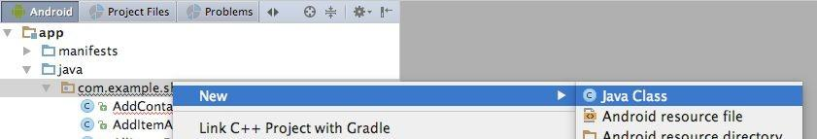

Name the class **Contact**. Hit **Enter**.

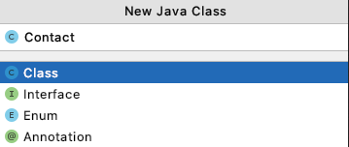

This creates an empty **Contact** class.

Now, it’s your turn to Implement the **Contact** methods provided in the Updated UML Class diagram. Make sure you implement **all the attributes and methods** in the **Contact** class.

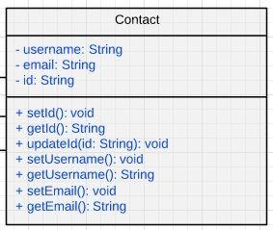

**Hints**

The implementation of the **Contact** constructor is:

**public** Contact(String username, String email, String id) {

**this**.**username** = username;

**this**.**email** = email;

**if** (id == **null**){

setId();

} **else** {

updateId(id);

}

}

And the **setId()** and **updateId()** implementation is:

**public void** setId() {

**this**.**id** = UUID.*randomUUID*().toString();

}

**public void** updateId(String id){

**this**.**id** = id;

}

Notice that **UUID** is red and when you hover over it it gives you an error message, “Cannot resolve symbol ‘UUID’ ”.

To fix this you need to import Java support for UUIDs. To do this, add the following import line to the top of the **Contact** class.

import java.util.UUID;

**Now, it’s your turn to implement the rest of the attributes and methods!**

### **Create and Implement the ContactList Class**

As previously done, create a new class by right-clicking on the **com.example.sharingapp**

folder. **New** → **Java Class**

Name the class **ContactList**. Hit **Enter**.

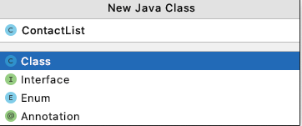

This creates an empty **ContactList** class.

Now, implement the **ContactList** methods provided in the Updated UML Class diagram. Make sure you implement **all the attributes and methods** in the **ContactList** class.

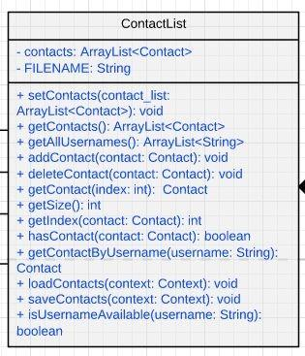

**Hints**

The implementation of the **ContactList** constructor is:

public ContactList() {

*contacts* = new ArrayList<Contact>();

}

The implementation of many of the methods in **ContactList** are analogous to those methods in **ItemList**. For example, the methods **loadContacts()** and **saveContacts()** are **completely analogous** to the **loadItems()** and **saveItems()** methods in the **ItemList** class.

If you use some of the code from the ItemList class, you may notice that you get a lot of import errors. Recall that you can click the red text and press **alt** and **enter** at the same time to import the necessary things. Alternatively, you can copy the imports from the **ItemList** class file to the top of your **ContactList** class file.

### **Run the App**

Assuming you have correctly implemented the **Contact** and **ContactList** classes, and do not have any remaining imports to be added to your project, at this point you should be able to run the app by clicking the **play** button.



Be patient! It may take a few minutes to launch SharingApp.